# Weekly Meeting Minutes: Thursday 3/7/2019

Jawaher, Dreighton, Chris, and Daniel

Joel - Clean up and repair any changes to report from last semester (parts 1-6. Already done).

**7 IMPLEMENTATION – Second Semester 7.1 Manufacturing**

Provide a detailed discussion of all the methods of manufacturing necessary to complete this project in the second semester. Detailed breakdown of all resources needed. Complete bill of materials, if appropriate, in Appendix, unless short. Sourcing, costs and budget. Detailed schedule of all implementation tasks.

PANEL FIX - DESCRIPTION - BILL OF MATERIALS

(Chris, Dreighton, and Joel)

-->In order to execute the proposed plan, the team scheduled an appointment with “Campus Services” to have skilled professionals execute the needed skilled labor. Campus Services provided services such as cutting and soldering. Campus Services recommended an alternative solution compared to the proposed plan. Instead of making four cuts and solder four times down the center of the panel, Campus Services proposed to instead make two cuts and solder twice.

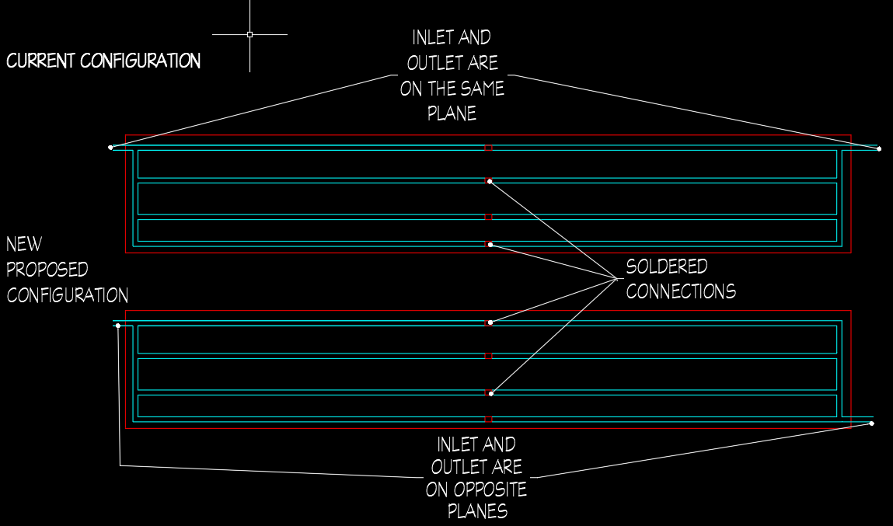

Figure #: Proposed Plan

**7 IMPLEMENTATION 7.2 Design Changes**

Discuss how the implementation actually occurred and describe problems encountered. Update this section as the project progresses and add sections as necessary if the design is subsequently changed due to implementation problems.

(Daniel and Jawaher)

TALK ABOUT PAUL’S CHANGES TO THE PROJECT. I.E. NO MORE SOLAR THERMAL - WANT DIFFERENT RENEWABLES. PV, WIND, RACKING, SALVAGE, ECT.

MAIN TAKEAWAYS FROM INDIVIDUAL ANALYSIS

* *Panel Racking FEA* - Chris
* *Wind Power*- Dreighton
* *PV options* - Daniel
* *Salvage* - Jawaher
* *Panel Analysis* - Joel

(Everyone) - Create executive summary of individual analysis for part 7.2 (Half-Page)